# Lab Assessment 1

## Name: Anuran Roy Reg. No: 20BCT0343

Page1.html:

Code:

<!DOCTYPE html>

<html lang="en">

<head>

<meta charset="UTF-8" />

<meta http-equiv="X-UA-Compatible" content="IE=edge" />

<meta name="viewport" content="width=device-width, initial-scale=1.0" />

<title>Document</title>

</head>

<style>

fieldset {

max-width: 50%;

}

</style>

<body>

<center>

<h1>Create your account:</h1>

<form method="GET" action="./page2.html">

<fieldset>

<label for="email">E-mail address:</label><br />

<input type="email" id="email" required/>

<hr />

<label for="password">Password:</label><br />

<input type="password" id="password" required/>

<hr />

<label for="confirm">Confirm Password:</label><br />

<input type="password" id="confirm" required/>

</fieldset>

<br>

<button type="submit">Next</button>

</center>

</form>

</body>

</html>

Screenshot:

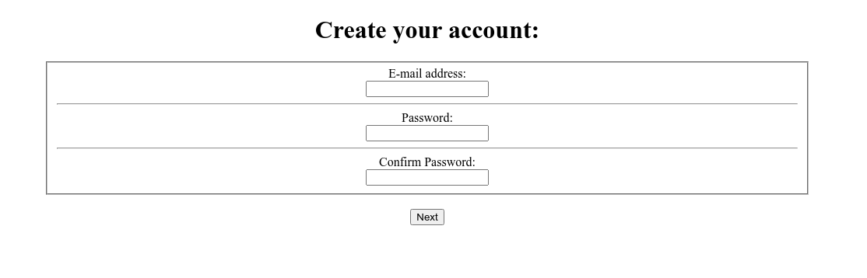

Page 2:

Code:

<!DOCTYPE html>

<html lang="en">

<head>

<meta charset="UTF-8" />

<meta http-equiv="X-UA-Compatible" content="IE=edge" />

<meta name="viewport" content="width=device-width, initial-scale=1.0" />

<title>Document</title>

</head>

<style>

fieldset {

max-width: 50%;

}

</style>

<body>

<center>

<h1>Educational Profiles:</h1>

<form method="GET" action="./page3.html">

<fieldset>

<label for="education">Education:</label><br />

<select name="education" id="education" required>

<option value="bachelor's">Bachelor's</option>

<option value="hs">Higher Secondary/Diploma</option>

<option value="sec">Secondary</option>

<option value="voc">Vocational</option>

</select>

<hr />

<label for="marks">Marks obtained:</label><br />

<input type="number" min="0" max="100" id="marks" required/>

<hr />

<label for="year">Passing Year:</label><br />

<input type="number" min="1950" max="2026" id="year" required/>

</fieldset>

<br />

<button type="submit">Next</button>

</form>

<a href="./page1.html"><button>Previous</button></a>

</center>

</body>

</html>

Screenshot:

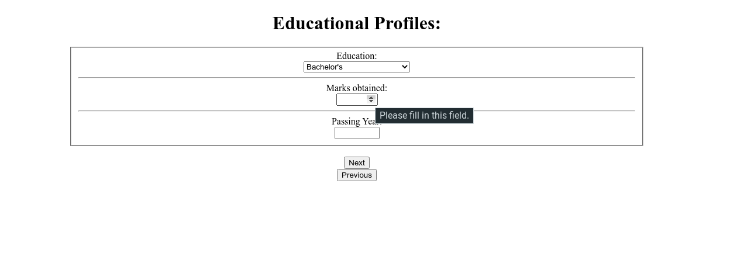

Page 3:

Code:

<!DOCTYPE html>

<html lang="en">

<head>

<meta charset="UTF-8" />

<meta http-equiv="X-UA-Compatible" content="IE=edge" />

<meta name="viewport" content="width=device-width, initial-scale=1.0" />

<title>Document</title>

</head>

<style>

fieldset {

max-width: 50%;

}

</style>

<body>

<center>

<h1>Personal Details:</h1>

<form method="GET" action="./page4.html">

<fieldset>

<label for="fName">First Name:</label><br />

<input type="text" id="fName" required/>

<hr />

<label for="lName">Last Name:</label><br />

<input type="text" id="lName" />

<hr />

<label for="contact">Contact Number:</label><br />

<input type="tel" id="contact" required/>

<hr />

<label for="Gender">Gender:</label><br />

<input type="radio" id="genderMale" name="Gender" value="M" required="required">

<label for="genderMale">Male</label>

<input type="radio" id="genderFemale" name="Gender" value="F">

<label for="genderFemale">Female</label>

<input type="radio" id="genderOther" name="Gender" value="O">

<label for="genderOther">Other</label>

<hr />

<label for="address">Address:</label><br />

<textarea id="address" placeholder="Enter your address" required>

</textarea>

</fieldset>

<br />

<button type="submit">Submit</button>

</form>

<a href="./page2.html"><button>Previous</button></a>

</center>

</body>

</html>

Screenshot:

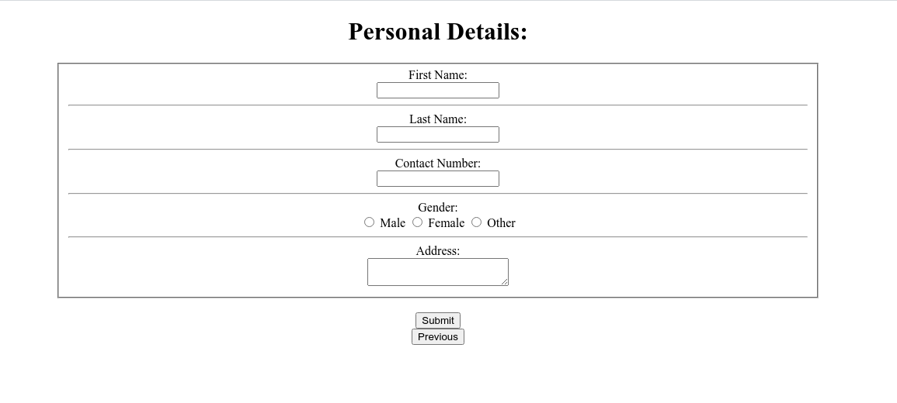

Page 4:

Code:

<!DOCTYPE html>

<html lang="en">

<head>

<meta charset="UTF-8" />

<meta http-equiv="X-UA-Compatible" content="IE=edge" />

<meta name="viewport" content="width=device-width, initial-scale=1.0" />

<title>Document</title>

</head>

<body>

<h1>Thanks, your response was submitted!</h1>

</body>

</html>

Screenshot:

